UNESCO: Marine pollution

TABLE OF CONTENTS

Marine Pollution

What is polluting our Oceans?
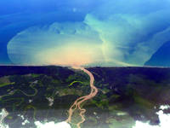
Land-based sources (such as agricultural run-off, discharge of nutrients and pesticides and untreated sewage including plastics) account for approximately 80% of marine pollution, globally. Marine habitats worldwide are contaminated with man-made debris. Oil spills remain a concern, though actual spills have decreased steadily for several decades.

How is this pollution threatening our Oceans?
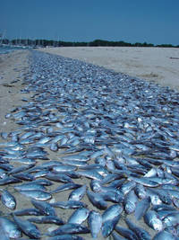
Picture 1 © Chris Deacutis
Excessive nutrients from sewage outfalls and agricultural runoff have contributed to the increasing incidence of low oxygen (hypoxic) areas known as dead zones, where most marine life cannot survive, resulting in the collapse of some ecosystems. There are now close to 500 dead zones with a total global surface area of over 245 000 km², roughly equivalent to that of the United Kingdom. The excess nitrogen can also stimulate the proliferation of seaweeds and microorganisms and cause algal blooms. Such blooms can be harmful (HABs), causing massive fish kills, contaminating seafood with toxins and altering ecosystems.
Litter can accumulate in huge floating garbage patches or wash up on the coasts. Light, resistant plastics float in the Oceans, releasing contaminants as they break down into toxic micro-particles that animals mistake for food. Fish and birds can choke on these particles, get sick as they accumulate in their stomachs, or become entangled in larger debris.
As the world saw in 2010, the Gulf of Mexico deep-water oil spill had a devastating effect on the entire marine ecosystem, as well as the populations that depend on the marine areas for their livelihoods. Smaller oil spills happen every day, due to drilling incidents or leaking motors, and cause the death of birds, marine mammals, algae, fish and shellfish.

How does this affect me?
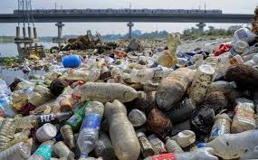
Picture 2: © IOC UNESCO
Some beaches are already closed to the public because the water is unsuitable for bathing and the beach is covered with litter. Micro-plastics and plastic pellets are found on most beaches around the world. Pollution also poisons our food. The toxins and plastic ingested by fish and shellfish end up in our plates, and the consumption of shellfish and other seafood is often banned briefly to avoid food poisoning.
This pollution costs the fishing and shipping industry millions of dollars:
- Discarded plastic bags get caught in boat propellers and cooling intakes, damaging the engines.
- Loss of habitat and biodiversity is increasingly impairing the ocean’s capacity to provide food and other services. The extinction of fish species could lead to starvation or under-nourishment.
- Ghost fishing that occurs when discarded fishing nets entangle marine life indiscriminately, as they continue to float in the oceans, reduce fishers’ revenues from lost catch.
Competition over declining resources and services provided by the oceans can cause tensions and conflicts locally and internationally.
A culture of peace is a culture of sustainable development
The oceans are a vital source of nourishment, especially to people in the world’s poorest nations. Many depend on fish for their primary source of protein; fisheries and aquaculture support the livelihoods of about 540 million people (8% of the world’s population) directly or indirectly. Overfishing, loss of biodiversity and the possible extinction of species put a stress on these limited resources. This could lead to famine, increased poverty and conflicts, including war. Learning to manage our ocean sustainably is the only path to global prosperity and peace.

What can I do?
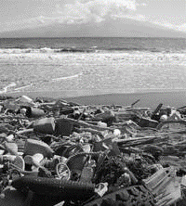
Picture 3: © NOAA
- Find out as much as you can about this problem and educate your friends.
- Get involved: there are probably clean-up efforts happening near you!
- Do not discard anything near the coast, when you go to the beach make sure you pick up after yourself.
- Ban toxic products from your boat-maintenance and do not throw anything overboard. Use and overflow system to avoid oil spills, and maintain your boat regularly to avoid leaks.
- Try to green your household and gardening chemical products, use them sparingly and wisely. Do not use fertilizers before it rains or pour oil or chemicals down the drain: they would just end up in the ocean!
- Try to avoid using single-serving plastic items and replace them by reusable items (cloth bags, reusable cups and silverware, non-plastic bottles).
- Refuse excess packaging, try to re-use and recycle as much as possible. Remember that very little of the plastic produced each year is actually recycled and much of it finds its way to the oceans.

What is IOC UNESCO doing?
IOC UNESCO (Question 2.6) believes that science in support of sustainable management is the cornerstone of the preservation of our oceans and their resources. Its Nutrients and Coastal Impacts Research Programme focuses on interactions between climate, nutrients, and coastal dynamics, and the challenges and opportunities that resulting ecosystem changes pose for tourism, institutions and governance. Through this activity, IOC is an active partner in the Global Partnership for Nutrient Management, which strives to deliver better tools for management of nutrient loading to the marine environment.
Its Harmful Algal Bloom Programme aims to foster the effective management of, and scientific research on, harmful algal blooms in order to understand their causes, predict their occurrences, and mitigate their effects.
Little is known about the full environmental impacts of marine litter, especially in the open oceans where there is almost no information. Trends over time and the effectiveness of management systems are hard to assess without good monitoring methodologies. IOC UNESCO and the UNEP published Guidelines on Survey and Monitoring of Marine Litter to assist policy makers in addressing this problem of monitoring and assessment of marine litter.
IOC UNESCO is a sponsor of the joint Group of Experts on the Scientific Aspects of Marine Environmental Protection (GESAMP), the United Nations mechanism for collaboration and coordination which conducts assessments and in-depth studies to evaluate the state of the marine environment, including socio-economic aspects, and identify emerging issues. The Commission is coordinating the GESAMP Working Group 40 on ‘Sources, fate and effects of micro-plastics in the environment’.
Keeping the world's oceans and seas under continuing review by integrating existing information from different disciplines will help to improve the responses from national governments and the international community to the unprecedented environmental changes now occurring.
INSERT HERE:

